CITY UNIVERSITY

Submitted By

Masud Rana

ID: 171442507

Program: B.sc in CSE (Day)

Batch: 44th

Submitted To

Richard Philip

Lecturer

Dept. of CSE

CITY UNIVERSITY

**DATA STRUCTURE**

Array 3

1D ARRAY: 4

2D ARRAY: 4

Stack 5

Basic Operations 5

Push Operation 6

Pop Operation 7

Queue 9

Queue Representation 9

Basic Operations 10

Enqueue Operation 10

Dequeue Operation 11

Linked List 14

Linked List Representation 14

Types of Linked List 14

Basic Operations 15

Insertion Operation 15

Deletion Operation 16

Reverse Operation 17

# Array

Arrays a kind of data structure that can store a fixed-size sequential collection of elements of the same type. An array is used to store a collection of data, but it is often more useful to think of an array as a collection of variables of the same type.

Instead of declaring individual variables, such as number0, number1, ..., and number99, you declare one array variable such as numbers and use numbers[0], numbers[1], and ..., numbers[99] to represent individual variables. A specific element in an array is accessed by an index.

All arrays consist of contiguous memory locations. The lowest address corresponds to the first element and the highest address to the last element.

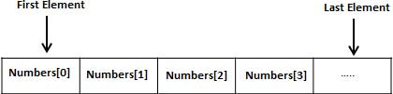

## 1D ARRAY:

An array is a data structure which can store multiple homogenous data elements under one name.

Suppose you want to store age of 50 students using a programming language. This can be done by taking 50 different variables for each student. But it is not easy to handle 50 different variables for this.

An alternative to this is arrays where we need not declare 50 variables for 50 students. When a list of data item is specified under one name using a single subscript, then such a variable is called a one dimensional (1-D) array. An array is declared in following way:

Specifies type of element such as int, float, char etc .and size indicates maximum number of elements that can be stored inside the array.

## 2D ARRAY:

Implementing a database of information as a collection of arrays can be inconvenient when we have to pass many arrays to utility functions to process the database. It would be nice to have a single data structure which can hold all the information, and pass it all at once.

**2-dimensional arrays** provide most of this capability. Like a 1D array, a 2D array is a collection of data cells, all of the same type, which can be given a single name. However, a 2D array is organized as a matrix with a number of rows and columns.

# Stack

The following diagram depicts a stack and its operations −

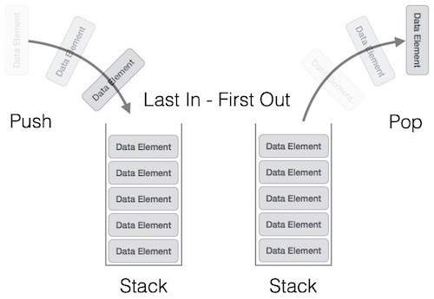

A stack can be implemented by means of Array, Structure, Pointer, and Linked List. Stack can either be a fixed size one or it may have a sense of dynamic resizing. Here, we are going to implement stack using arrays, which makes it a fixed size stack implementation.

## Basic Operations

Stack operations may involve initializing the stack, using it and then de-initializing it. Apart from these basic stuffs, a stack is used for the following two primary operations −

* **push()** − Pushing (storing) an element on the stack.
* **pop()** − Removing (accessing) an element from the stack.

When data is PUSHed onto stack.

To use a stack efficiently, we need to check the status of stack as well. For the same purpose, the following functionality is added to stacks −

* **peek()** − get the top data element of the stack, without removing it.
* **isFull()** − check if stack is full.
* **isEmpty()** − check if stack is empty.

At all times, we maintain a pointer to the last PUSHed data on the stack. As this pointer always represents the top of the stack, hence named **top**. The **top**pointer provides top value of the stack without actually removing it.

## Push Operation

The process of putting a new data element onto stack is known as a Push Operation. Push operation involves a series of steps −

* **Step 1** − Checks if the stack is full.
* **Step 2** − If the stack is full, produces an error and exit.
* **Step 3** − If the stack is not full, increments **top** to point next empty space.
* **Step 4** − Adds data element to the stack location, where top is pointing.
* **Step 5** − Returns success.

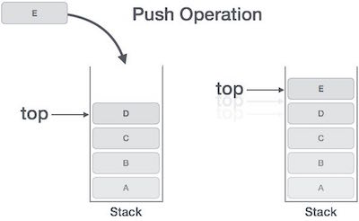

If the linked list is used to implement the stack, then in step 3, we need to allocate space dynamically.

## Pop Operation

Accessing the content while removing it from the stack, is known as a Pop Operation. In an array implementation of pop() operation, the data element is not actually removed, instead **top** is decremented to a lower position in the stack to point to the next value. But in linked-list implementation, pop() actually removes data element and deallocates memory space.

A Pop operation may involve the following steps −

* **Step 1** − Checks if the stack is empty.
* **Step 2** − If the stack is empty, produces an error and exit.
* **Step 3** − If the stack is not empty, accesses the data element at which **top** is pointing.
* **Step 4** − Decreases the value of top by 1.
* **Step 5** − Returns success.

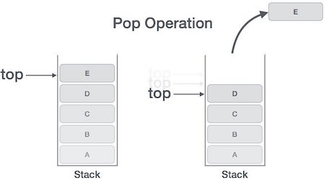

# Queue

Queue is an abstract data structure, somewhat similar to Stacks. Unlike stacks, a queue is open at both its ends. One end is always used to insert data (enqueue) and the other is used to remove data (dequeue). Queue follows First-In-First-Out methodology, i.e., the data item stored first will be accessed first.



A real-world example of queue can be a single-lane one-way road, where the vehicle enters first, exits first. More real-world examples can be seen as queues at the ticket windows and bus-stops.

## Queue Representation

As we now understand that in queue, we access both ends for different reasons. The following diagram given below tries to explain queue representation as data structure −

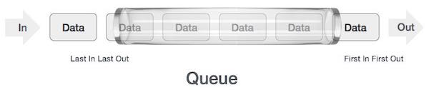

As in stacks, a queue can also be implemented using Arrays, Linked-lists, Pointers and Structures. For the sake of simplicity, we shall implement queues using one-dimensional array.

## Basic Operations

Queue operations may involve initializing or defining the queue, utilizing it, and then completely erasing it from the memory. Here we shall try to understand the basic operations associated with queues −

* **enqueue()** − add (store) an item to the queue.
* **dequeue()** − remove (access) an item from the queue.

Few more functions are required to make the above-mentioned queue operation efficient. These are −

* **peek()** − Gets the element at the front of the queue without removing it.
* **isfull()** − Checks if the queue is full.
* **isempty()** − Checks if the queue is empty.

In queue, we always dequeue (or access) data, pointed by **front** pointer and while enqueing (or storing) data in the queue we take help of **rear** pointer.

## Enqueue Operation

Queues maintain two data pointers, **front** and **rear**. Therefore, its operations are comparatively difficult to implement than that of stacks.

The following steps should be taken to enqueue (insert) data into a queue −

* **Step 1** − Check if the queue is full.
* **Step 2** − If the queue is full, produce overflow error and exit.
* **Step 3** − If the queue is not full, increment **rear** pointer to point the next empty space.
* **Step 4** − Add data element to the queue location, where the rear is pointing.
* **Step 5** − return success.

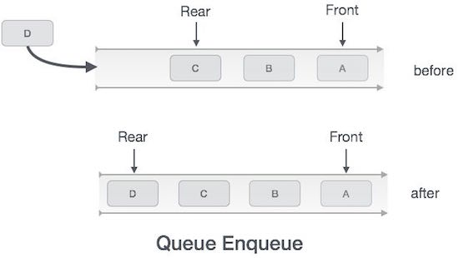

Sometimes, we also check to see if a queue is initialized or not, to handle any unforeseen situations.

## Dequeue Operation

Accessing data from the queue is a process of two tasks − access the data where **front** is pointing and remove the data after access. The following steps are taken to perform **dequeue** operation −

* **Step 1** − Check if the queue is empty.
* **Step 2** − If the queue is empty, produce underflow error and exit.
* **Step 3** − If the queue is not empty, access the data where **front** is pointing.
* **Step 4** − Increment **front** pointer to point to the next available data element.
* **Step 5** − Return success.

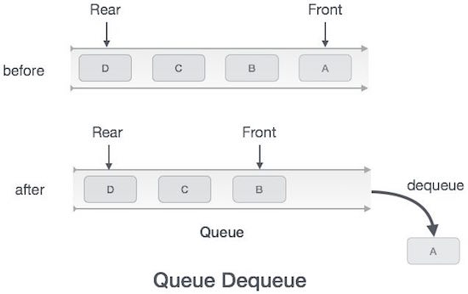

# Linked List

A linked list is a sequence of data structures, which are connected together via links.

Linked List is a sequence of links which contains items. Each link contains a connection to another link. Linked list is the second most-used data structure after array. Following are the important terms to understand the concept of Linked List.

* **Link** − Each link of a linked list can store a data called an element.
* **Next** − Each link of a linked list contains a link to the next link called Next.
* **LinkedList** − A Linked List contains the connection link to the first link called First.

## Linked List Representation

Linked list can be visualized as a chain of nodes, where every node points to the next node.

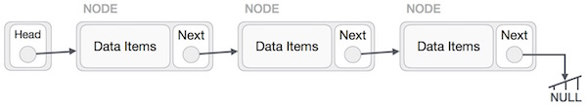

As per the above illustration, following are the important points to be considered.

* Linked List contains a link element called first.
* Each link carries a data field(s) and a link field called next.
* Each link is linked with its next link using its next link.
* Last link carries a link as null to mark the end of the list.

## Types of Linked List

Following are the various types of linked list.

* **Simple Linked List** − Item navigation is forward only.
* **Doubly Linked List** − Items can be navigated forward and backward.
* **Circular Linked List** − Last item contains link of the first element as next and the first element has a link to the last element as previous.

## Basic Operations

Following are the basic operations supported by a list.

* **Insertion** − Adds an element at the beginning of the list.
* **Deletion** − Deletes an element at the beginning of the list.
* **Display** − Displays the complete list.
* **Search** − Searches an element using the given key.
* **Delete** − Deletes an element using the given key.

## Insertion Operation

Adding a new node in linked list is a more than one step activity. We shall learn this with diagrams here. First, create a node using the same structure and find the location where it has to be inserted.

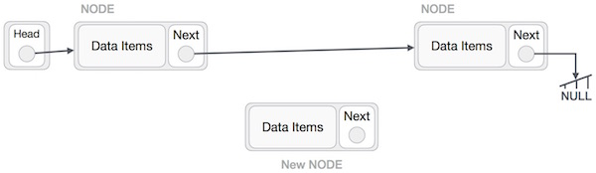

Imagine that we are inserting a node **B** (NewNode), between **A** (LeftNode) and **C** (RightNode). Then point B.next to C −

NewNode.next −> RightNode;

It should look like this −

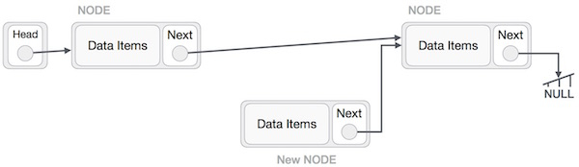

Now, the next node at the left should point to the new node.

LeftNode.next −> NewNode;

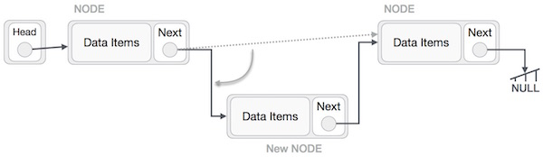

This will put the new node in the middle of the two. The new list should look like this −

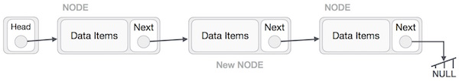

Similar steps should be taken if the node is being inserted at the beginning of the list. While inserting it at the end, the second last node of the list should point to the new node and the new node will point to NULL.

## Deletion Operation

Deletion is also a more than one step process. We shall learn with pictorial representation. First, locate the target node to be removed, by using searching algorithms.

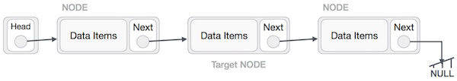

The left (previous) node of the target node now should point to the next node of the target node −

LeftNode.next −> TargetNode.next;

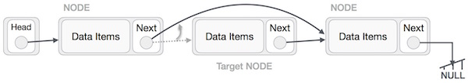

This will remove the link that was pointing to the target node. Now, using the following code, we will remove what the target node is pointing at.

TargetNode.next −> NULL;

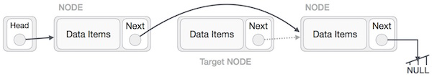

We need to use the deleted node. We can keep that in memory otherwise we can simply deallocate memory and wipe off the target node completely.

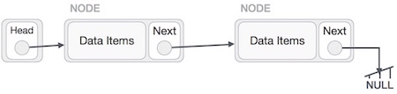

## Reverse Operation

This operation is a thorough one. We need to make the last node to be pointed by the head node and reverse the whole linked list.

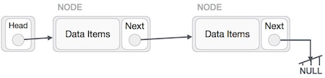

First, we traverse to the end of the list. It should be pointing to NULL. Now, we shall make it point to its previous node −

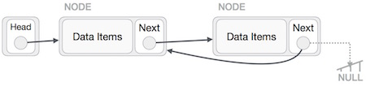

We have to make sure that the last node is not the lost node. So we'll have some temp node, which looks like the head node pointing to the last node. Now, we shall make all left side nodes point to their previous nodes one by one.

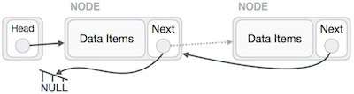

Except the node (first node) pointed by the head node, all nodes should point to their predecessor, making them their new successor. The first node will point to NULL.

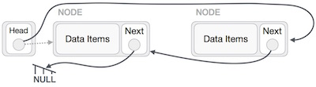

We'll make the head node point to the new first node by using the temp node.

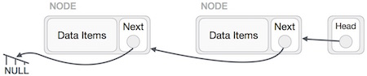

The linked list is now reversed. To see linked list implementation in C programming language, please [click here](https://www.tutorialspoint.com/data_structures_algorithms/linked_list_program_in_c.htm).

1.[Tutorial Point.](https://www.tutorialspoint.com/cprogramming/c_arrays.htm)

2.[Tutorial Point](https://www.tutorialspoint.com/data_structures_algorithms/stack_program_in_c.htm)

3.[Tutorial Point](https://www.tutorialspoint.com/data_structures_algorithms/dsa_queue.htm)

4.[Tutorial Point](https://www.tutorialspoint.com/data_structures_algorithms/linked_list_program_in_c.htm)